ASE LAB9 Assignment

IBM Bluemix Deployment and Design Patterns

Design Patterns:

1. Singleton Pattern:

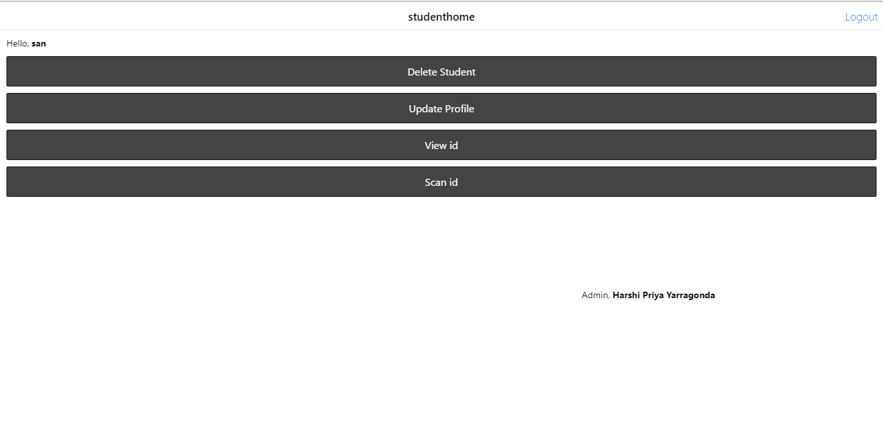

Here we use the singleton pattern to display the admin name in all the pages. In the above page we can see “Admin, Harshi Priya Yarragonda” and this is the instance which we can use in every page.

Code for the singleton pattern is in the below screenshot

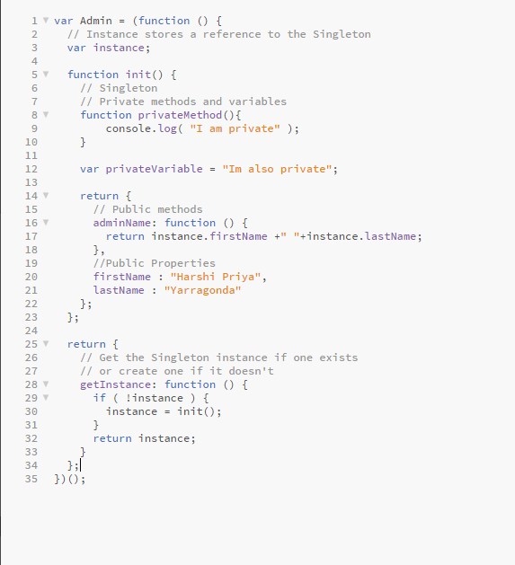

1. Mixin pattern:

In the Mixin pattern, we can avoid multiple inheritance by creating methods. I have used console.log for login, registration, delete and update pages. In the screenshot we can see “Inside http Get for retrieving”.

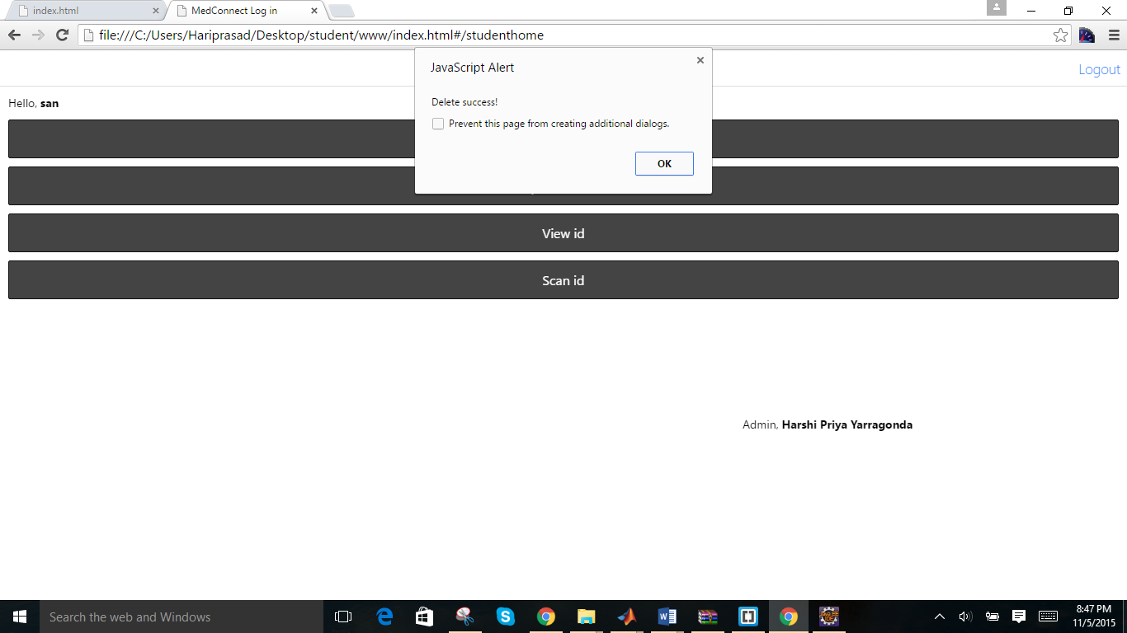

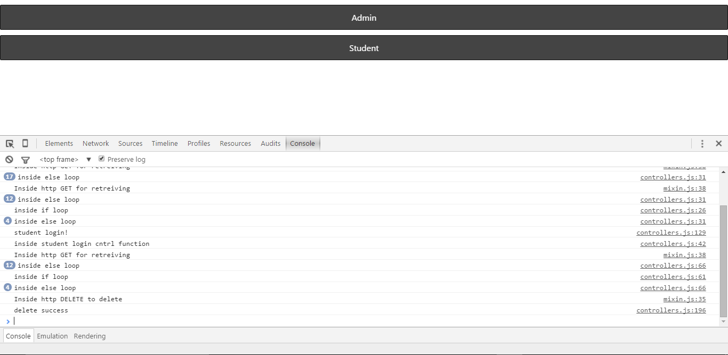

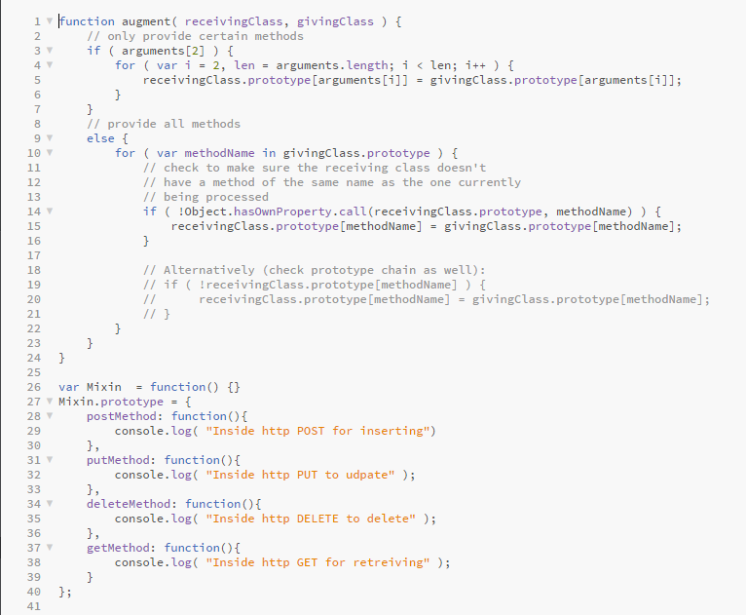

1. Factory Pattern:

We can display the name of the user after login into the account. In the screen shot we can see “Hello skTest” and it is displayed using factory pattern.

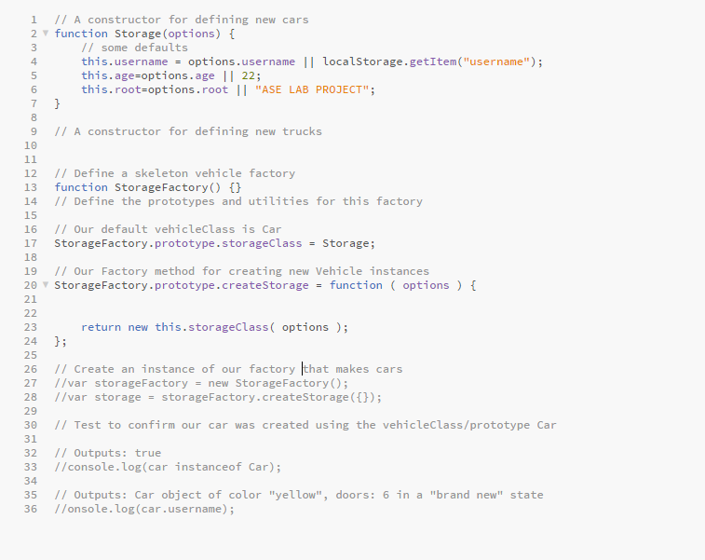

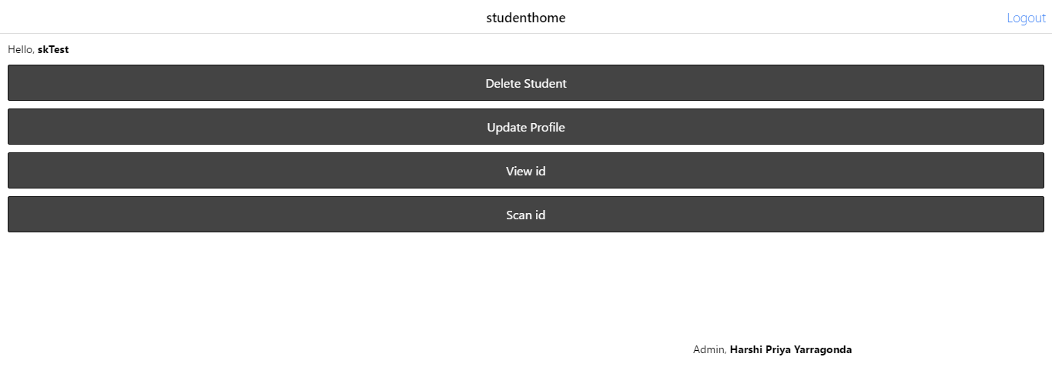

Bluemix Deployment:

